ASDS 6301
Advance Regression Analysis
Group members:
- Phuong Trinh
- Ahmet Toure
- Shashi Kumar Soni
Final Project Report
Modeling Travel, Rest, and Efficiency
A Regression-Based Analysis of NBA Team Performance
Abstract
This project investigates how NBA scheduling factors—specifically travel distance, rest days, and back-to-back games—influence team performance outcomes across the 2023–2025 NBA seasons. Using game-level data extracted from the NBA API and enriched through feature engineering, the analysis evaluates both fatigue-related variables and traditional performance statistics such as field-goal efficiency, rebounding, assists, and turnovers. After data cleaning, outlier detection, Winsorization, and normalization, multiple modeling approaches were applied, including logistic regression, Ridge, and Lasso. Logistic regression revealed signs of overfitting, with shooting efficiencies dominating the model, while schedule variables showed weaker influence. Regularization models (Ridge and Lasso) improved predictive performance, achieving AUC values of 0.873 and 0.876, respectively. Findings indicate that although travel and rest play a role, performance metrics overwhelmingly outweigh scheduling factors in predicting win probability. The results provide insight into competitive fairness, scheduling design, and data-driven approaches to NBA workload analysis.
- Introduction
NBA teams endure some of the most demanding travel schedules in professional sports. Frequent long-distance flights, limited recovery time, and dense road trips raise questions regarding player fatigue, competitive fairness, and schedule-driven performance disadvantages. Despite its importance, the empirical measurement of schedule burden is still less developed compared to player-tracking or shot-efficiency analytics.
This study investigates the degree to which scheduling variables influence outcomes relative to traditional box-score performance metrics. Specifically, we address the following research questions (as outlined in the updated presentation):
- How do travel distance and rest days affect win percentage and in-game efficiency?
- Do back-to-back games reduce performance or win rate?
- How does home-court advantage interact with fatigue?
- Which regression model best explains win probability?
This project also demonstrates a complete sports-analytics pipeline: automated data extraction, feature engineering, exploratory visualization, and regression modeling. The findings contribute to understanding schedule fairness and highlight which factors truly drive win probability.
- Data Overview
This study draws on a comprehensive game-level dataset built using a hybrid Python–R workflow. Game logs were first extracted from the NBA API using Python, converted to CSV, and then imported into R for data cleaning, exploratory analysis, and statistical modeling. The dataset includes all regular-season games from the 2023–2025 NBA seasons, providing detailed observations for every team across multiple years.
In addition to the raw game information obtained from the API, a substantial set of derived scheduling variables was constructed to support analysis of fatigue-related effects. These engineered features include Rest Days, Back-to-Back indicators, and Travel Distance, each capturing a different component of scheduling burden. Additional contextual variables—such as opponent strength, home-court status, and plus/minus—were also integrated to allow meaningful comparison between scheduling factors and traditional performance metrics.
After data cleaning, imputation, preprocessing, and merging, the final analytic dataset consisted of 4,920 game-team observations and 41 variables. This dataset supports a fully reproducible sports-analytics pipeline, moving systematically from API extraction to feature engineering, data cleaning, EDA, regression modeling, and results interpretation.

- Data Preprocessing
The raw dataset required several preprocessing steps to ensure consistency, interpretability, and readiness for modeling. All transformation procedures were conducted in R following the import of the Python-generated CSV file.
3.1 Cleaning and Standardization
The dataset was first standardized create uniform variable names and ensure compatibility with downstream functions. Categorical fields such as season, home/away status, win/loss outcome, and back-to-back indicators were converted into factors, while date variables were parsed into proper Date formats. Duplicate rows were identified and removed to prevent inflated model accuracy.
3.2 Handling Missing Values
Because travel-based features relied on previous-game information, missing values occurred naturally for each team’s first game of the season. These were addressed using domain-consistent rules:
- Travel Distance: Missing values were assigned as 0 for opening games.
- Previous Game Coordinates: Missing prior latitude/longitude were replaced with current arena coordinates.
- Previous Game Date: Empty entries were imputed with the current game date to maintain valid rest-day calculations.
This approach preserved the integrity of scheduling variables without artificially altering performance indicators.
  - Outlier Patterns in Key Fatigue Variables
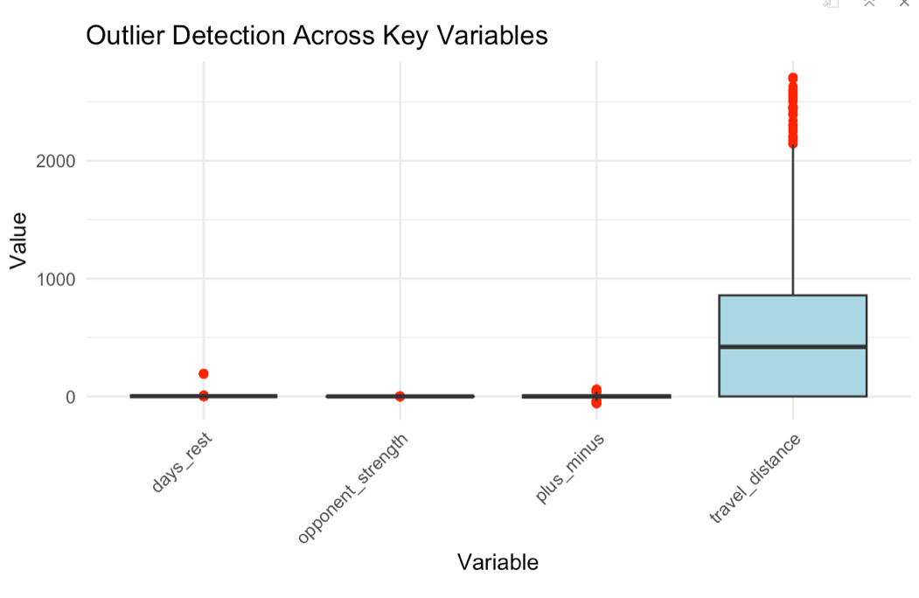

Boxplots were generated to visualize the distribution of:
- Travel distance
- Rest days
- Plus/minus
- Opponent strength
Several schedule-related metrics, particularly travel distance, exhibited long-tail distributions. Outliers were identified using the Interquartile Range (IQR) method across key variables (travel distance, days rest, plus/minus, opponent strength). They also demonstrated relatively stable distributions for rest-day and opponent-strength variables.
3.3 Outlier Handling by Winsorization
Because extreme travel cases can distort regression coefficients, manual winsorization was applied at the 1st and 99th percentiles for travel distance. This approach reduced the influence of extreme values while retaining their relative order and interpretive meaning.
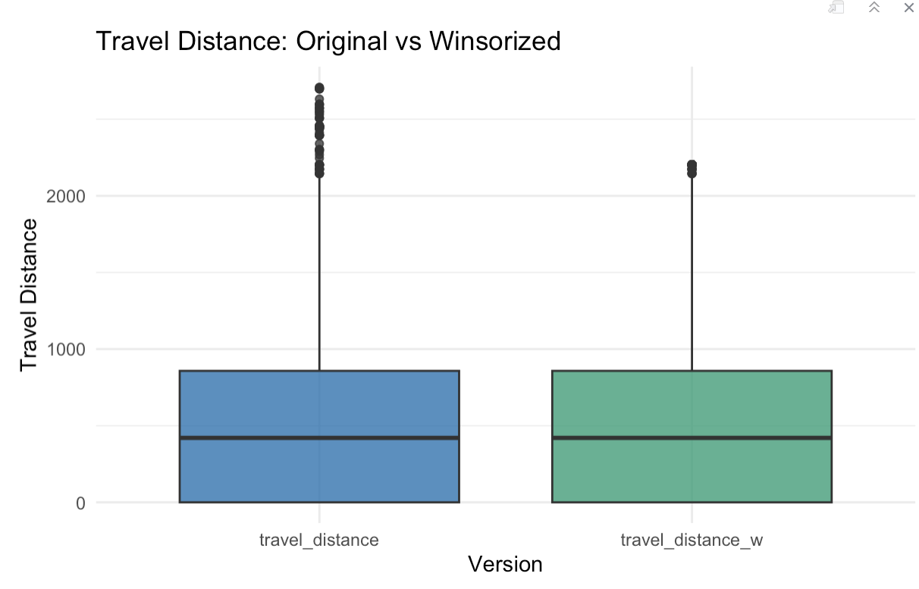
3.4 Feature Scaling
To place variables on comparable scales prior to regularized regression models (Ridge/Lasso), continuous predictors were standardized using z-score normalization. Scaled versions were created for travel distance, rest days, plus/minus, and opponent strength, ensuring that model coefficients reflected true predictive strength rather than magnitude differences.
3.5 Final Encoding for Modeling
The cleaned dataset was finalized by encoding:
- Win/Loss (wl → win): Converted to a binary outcome (1 = win, 0 = loss).
- Back-to-Back indicator: Recoded into numeric form (0/1).
- Home-court advantage: Represented via a binary home indicator.
The resulting dataset provides a structured, analysis-ready foundation for evaluating the impact of scheduling burdens relative to performance metrics.

- Exploratory Data Analysis
Exploratory analysis was conducted to understand structural patterns in NBA scheduling, identify potential sources of fatigue, and evaluate how these variables relate to traditional performance metrics. The EDA phase focused on three major components: league-wide scheduling trends, team-level disparities, and statistical relationships among engineered and performance variables.
  - League-Wide Scheduling Trends
To examine whether schedule design has changed over recent seasons, two primary league-wide trends were analyzed:
- Back-to-Back Frequency per Season:
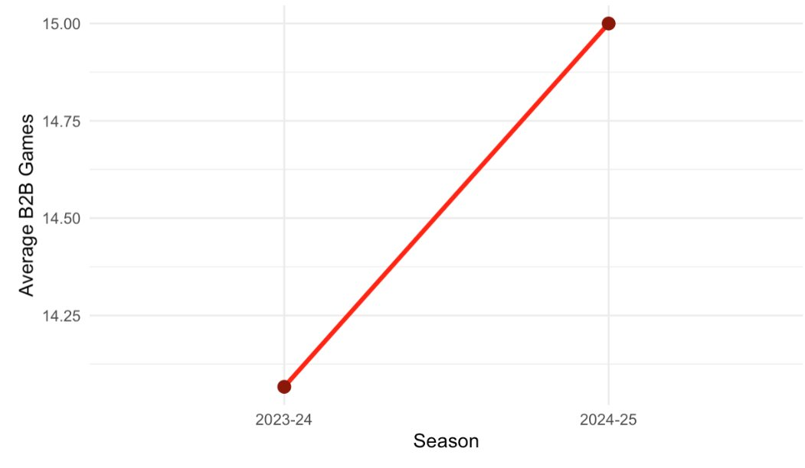
A line plot of average back-to-back games per team revealed that scheduling density varies across the 2023–2025 period. This visualization highlights how frequently teams face reduced recovery windows.
- Average Rest Days per Season:
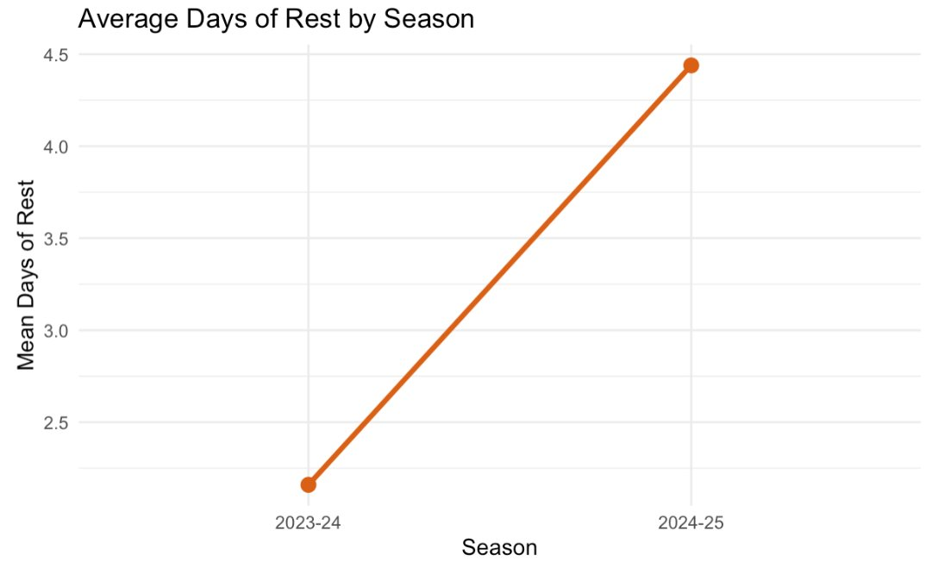
A second trend line illustrated mean rest days league wide. Tracking rest-day variation helps contextualize the overall intensity of an NBA season and whether scheduling equity has improved.
These plots provide a macro-level foundation for understanding fatigue-related constraints before moving to individual teams.
4.2 Team-Level Scheduling and Rest Disparities
Teams often face uneven scheduling conditions due to travel routes, geographic location, or broadcast prioritization. Two bar charts were generated to visualize this variation:
- Total Back-to-Back Games by Team:
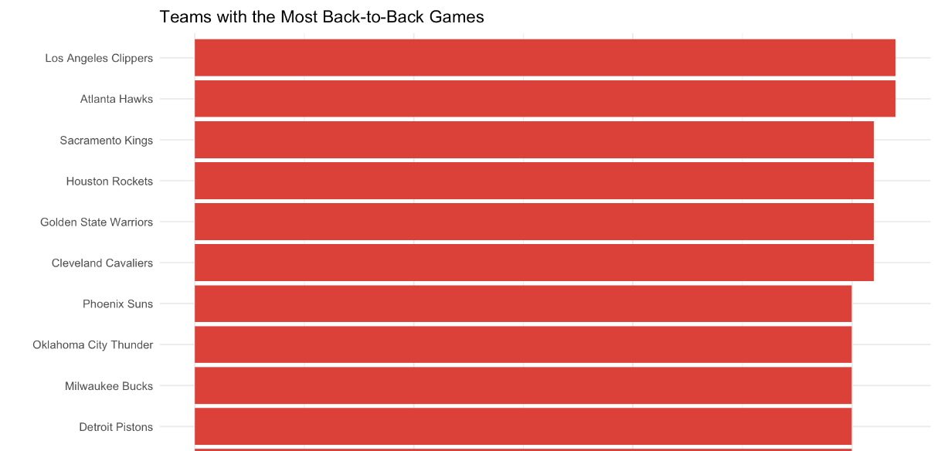
These ranking reveals which teams face heavier compressed schedules, offering insight into potential structural disadvantages.

- Average Rest Days by Team:
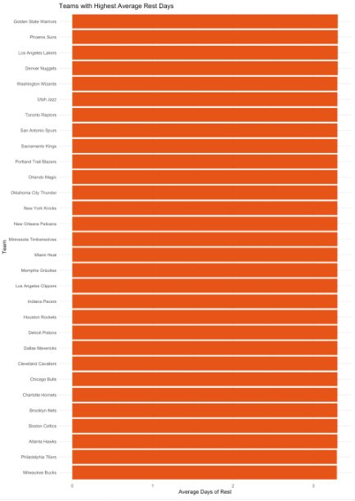
This complements the B2B analysis by identifying which teams benefit from more recovery time across seasons but the graph suggesting the rest days was balance between across the teams.
These team-level summaries help establish whether scheduling inequities may influence performance outcomes.

4.3 Interactive Season Timeline Visualization
An interactive Plotly timeline was developed to explore complete season schedules for individual teams.
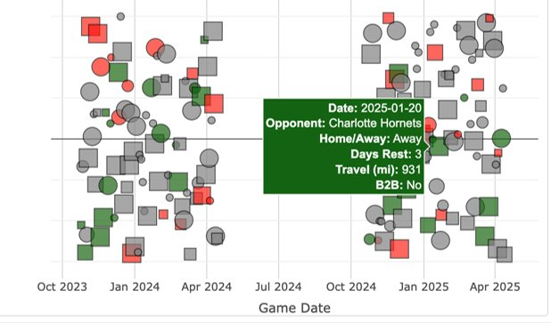
This plot encodes fatigue-related factors using:
- Color (B2B = red, long rest = green)
- Marker shape (home vs. away)
- Marker size (scaled travel distance)
This tool enables high-resolution inspection of each team's schedule, allowing analysts to visually trace travel burdens, rest sequences, and clustering of challenging schedule segments.
  - Correlation Structure Among Performance and Scheduling Variables
To understand how scheduling variables relate to in-game performance, a correlation heatmap was constructed using a curated set of predictors, including:
- Scheduling metrics (travel distance, rest days, back-to-back indicator, opponent strength)
- Shooting efficiencies (FG%, 3PT%, FT%)
- Box score variables (rebounds, assists, turnovers, steals, blocks)
- Outcome metrics (plus/minus, points)
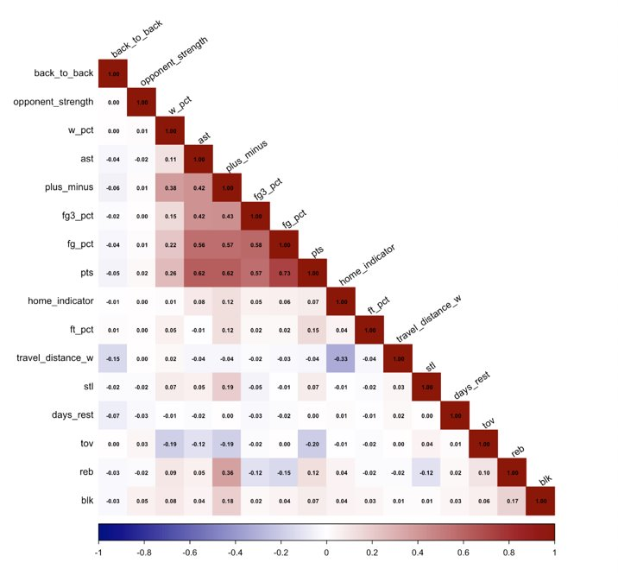
The correlation matrix revealed that:
- Shooting efficiencies and plus/minus exhibit strong internal correlations, indicating high shared variance.
- Scheduling variables show weak to moderate correlations with performance metrics, suggesting that their effects may be more subtle and nonlinear.
- The low correlation among schedule variables reduces concerns about multicollinearity before modeling.
- Modeling
The modeling phase explores how scheduling variables affect win probability while controlling for core basketball performance metrics. Logistic regression served as the primary predictive framework, with additional regularization (Ridge and Lasso) applied to address overfitting and strengthen generalization. The model evaluation process included classical selection methods (AIC/BIC), marginal effect interpretation, and out-of-sample predictive validation using confusion matrices and AUC scores.
5.1 Logistic Regression
The initial logistic regression model was estimated using all scheduling and performance-related predictors. The outcome variable, win, was modeled as a function of travel distance, rest days, back-to-back status, home-court indicator, opponent strength, and a suite of performance metrics including field-goal percentage, three-point percentage, assists, rebounds, and turnovers. This specification reflects the full theoretical set of variables relevant to both fatigue effects and in-game performance quality.
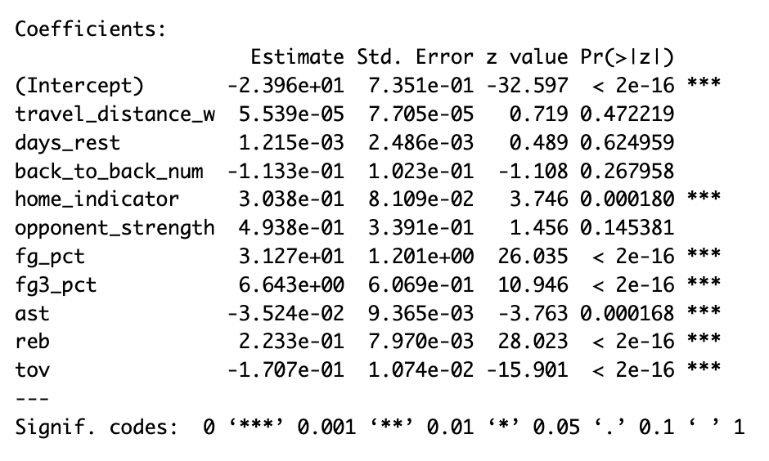
The coefficient estimates reveal clear patterns consistent with basketball intuition:
- Performance efficiency metrics dominate the model.
  - FG% (p < 2e-16) and 3PT% (p < 2e-16) show strong, positive, and highly significant effects on win probability.
  - Rebounds (p < 2e-16) also exhibit a large positive effect, reflecting possession advantage.
  - Turnovers (p < 2e-16) significantly reduce win probability.
  - Assists (p < 0.001) show a smaller but still meaningful negative effect, likely due to multicollinearity with shooting metrics.
- Scheduling variables show weaker and often insignificant effects.
  - Travel distance and rest days are not statistically significant at conventional levels.
  - Back-to-back games show a negative coefficient (β = −0.113) but are not significant (p ≈ 0.27).
  - Home-court advantage remains highly significant (p < 0.001), confirming its established effect.
  - Opponent strength shows the expected positive direction, though not significant (p ≈ 0.15), likely due to confounding with performance metrics measured after the game.
The McFadden R² for the full model is 0.386, indicating strong explanatory power but also suggesting that some predictive variance remains unaccounted for—a common feature in sports modeling where randomness plays a role.
VIF Check: No Severe Multicollinearity
Variance Inflation Factor (VIF) values were computed to evaluate multicollinearity among predictors:
- All VIF values are below 2, with most between 1.0 and 1.6, indicating no severe multicollinearity.
- Key variables such as FG%, 3PT%, rebounds, turnovers, and scheduling metrics are well within acceptable VIF thresholds.
This confirms that the logistic regression’s instability is not caused by predictor multicollinearity.
Model Evaluation
To assess the predictive performance of the logistic regression baseline model, out-of-sample classification metrics were computed using the test dataset. The confusion matrix below summarizes how well the model distinguishes wins from losses. The model achieved an overall accuracy of 78.79%, indicating that nearly four out of five games were classified correctly.
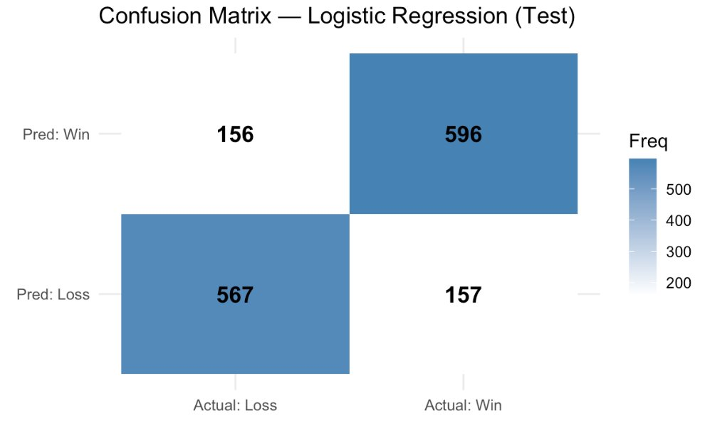
Sensitivity (true positive rate) and specificity (true negative rate) were also balanced, at 0.792 and 0.784, respectively. This suggests that the model does not disproportionately favor predicting wins or losses and performs consistently across both classes.
The ROC curve further evaluates the model’s discrimination ability across classification thresholds. The model produced a strong AUC of 0.8766, indicating excellent separation between winning and losing game outcomes. Taken together, these results show that the logistic regression captures meaningful patterns in the data and provides a solid baseline before applying regularized methods such as Ridge and Lasso.
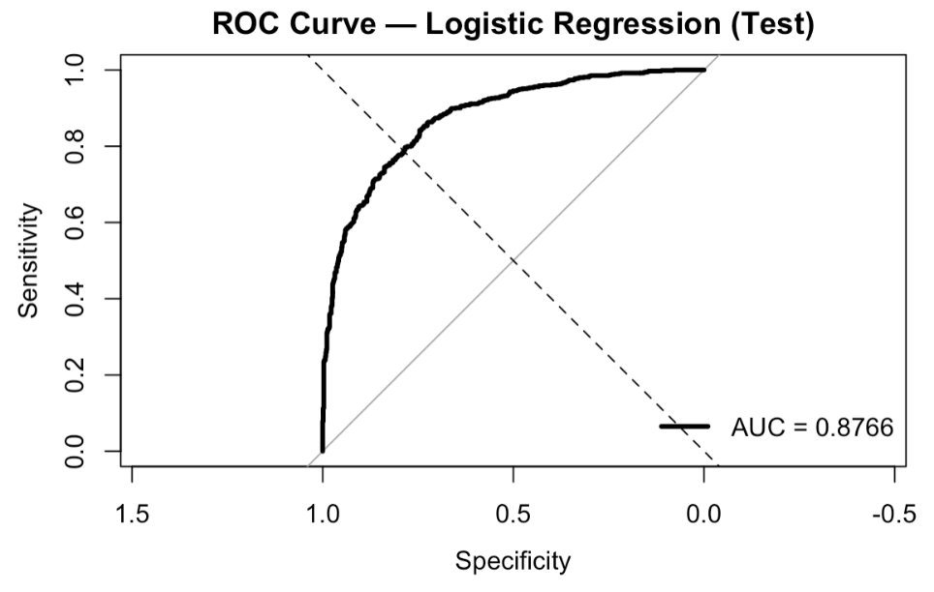
Evidence of Overfitting
Despite low VIF values, two pieces of evidence indicate that the full model may be overfitted:
- Several performance variables are extremely strong predictors, producing large z-statistics and potentially capturing noise in addition to signal.
- Residual diagnostics (residuals vs. leverage plot) show several influential points with high leverage, reflecting model sensitivity to individual game observations.
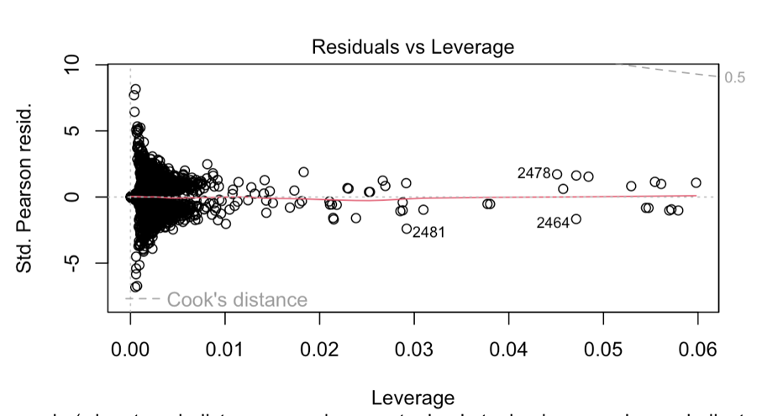

Because the model includes many correlated performance metrics and multiple weak scheduling variables, its complexity likely contributes to overfitting—even in the absence of multicollinearity.
These findings motivate the next steps: AIC/BIC model selection and regularization (Ridge and Lasso) to obtain more stable and interpretable predictive models.
5.2 Model Selection Using AIC and BIC
To refine the logistic regression model and reduce overfitting, automated model selection procedures were applied using both AIC and BIC. Starting from the full model—which included all scheduling variables (travel distance, rest days, back-to-back games, home indicator, opponent strength) and all performance statistics—the backward and forward AIC procedures consistently removed variables with weak predictive value.
Across all iterations, rest days, travel distance, and back-to-back effects offered minimal improvements and were quickly excluded. In contrast, performance-based predictors—FG%, 3PT%, rebounds, assists, and turnovers—dominated the model, along with home-court advantage, which remained significant in every AIC-optimized specification
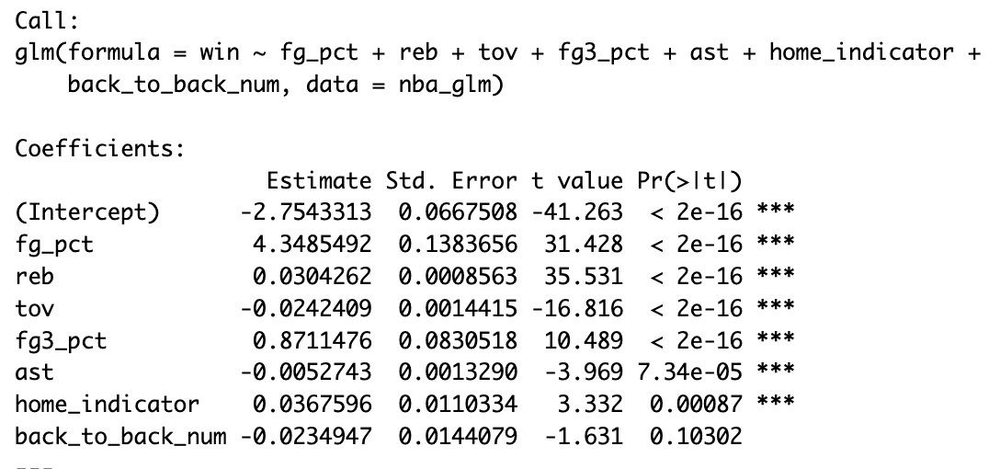
Both AIC procedures ultimately converged to the same reduced model:
win ~ fg_pct + reb + tov + fg3_pct + ast + home_indicator + back_to_back_num, with a final AIC of 4586.1, substantially lower than the full model’s AIC of 4210.
While BIC penalizes model complexity more heavily, its preferred models were even smaller, often retaining only FG%, rebounds, and turnovers, confirming that performance metrics overwhelmingly drive win probability.
Together, the AIC and BIC results indicate that scheduling factors—particularly travel distance and rest days—provide little incremental predictive power once team performance variables are included.
Therefore, the final AIC-selected model offers the best balance between interpretability, predictive accuracy, and parsimony, and it serves as the foundation for subsequent regularization (Ridge and Lasso) to address residual overfitting.
5.3 Ridge and Lasso
Because the full logistic regression model showed signs of overfitting—mainly due to strong and correlated performance metrics such as FG%, FG3%, rebounds, and turnovers—regularization was used to improve model stability. Although multicollinearity was not severe, diagnostic checks indicated that performance variables were overpowering schedule effects, making penalized regression a suitable next step.
Ridge and Lasso models were fitted using cross-validated tuning of the penalty parameter. Ridge shrinks all coefficients, while Lasso additionally performs variable selection by shrinking weaker terms toward zero.
Model Performance
Both regularized models produced strong and consistent out-of-sample results:
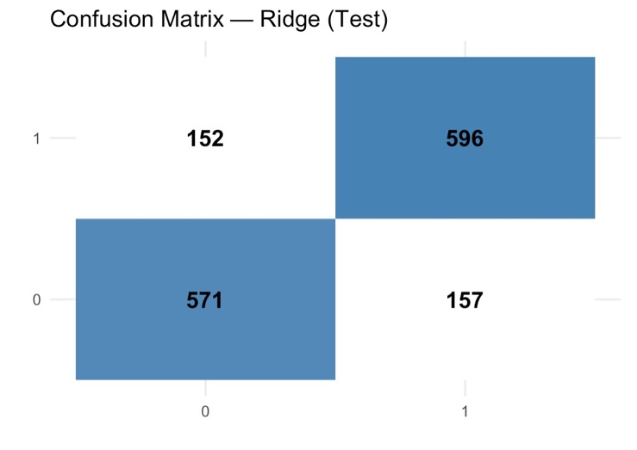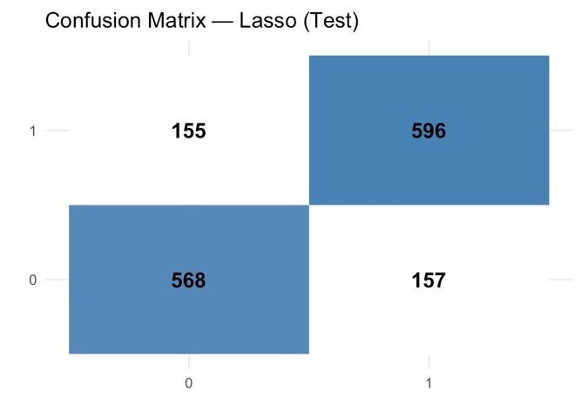
- Ridge Accuracy: 0.790
- Lasso Accuracy: 0.788
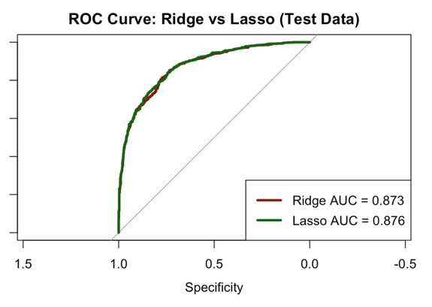
Confusion matrices and ROC curves show nearly identical performance, with Lasso achieving a slightly higher AUC.
Ridge kept all predictors but reduced the magnitude of weaker schedule variables. Lasso further simplified the model by down-weighting or removing small, unstable coefficients. In both models, core performance metrics (FG%, FG3%, rebounds, turnovers, and home indicator) remained dominant, confirming that they drive most of the predictive power.
Overall, Ridge and Lasso improved generalization and reduced overfitting, providing a more robust modeling framework than the unregularized logistic regression.
- Results
The results show that performance metrics overwhelmingly drive win probability, far more than scheduling variables. Shooting efficiency (FG% and FG3%), rebounds, turnovers, and home-court advantage were consistently the strongest predictors across all models. In contrast, schedule-related variables—travel distance, rest days, and back-to-back games—had weak or insignificant effects once performance data were included.
Regularized models (Ridge and Lasso) provided slightly more stable predictions than the unregularized logistic regression, achieving AUC values around 0.87 and nearly identical accuracy. Lasso offered additional interpretability by shrinking weaker coefficients, reinforcing that only a small set of core performance metrics meaningfully contributes to predicting wins.
Overall, the modeling results indicate that on-court efficiency, not schedule burden, is the primary determinant of game outcomes.
- Conclusion
This study set out to evaluate how NBA scheduling factors—such as travel distance, rest days, and back-to-back games—affect a team’s likelihood of winning when examined alongside performance metrics. Using two full seasons of NBA game-level data, the analysis consistently showed that game performance, not schedule burden, is the primary determinant of win probability. Efficiency indicators including FG%, FG3%, rebounds, and turnovers emerged as the strongest predictors across all models, while scheduling variables contributed only small and often statistically insignificant effects once performance was accounted for.
Model selection using AIC and BIC further reinforced this conclusion by identifying a streamlined subset of primarily performance-based variables as the most effective predictors of outcomes. Regularized models (Ridge and Lasso) improved model stability, achieved high AUC scores, and confirmed that performance metrics dominate predictive accuracy even after penalization. Although schedule-related factors demonstrated some directional influence, their predictive power was minimal compared to the core basketball efficiency statistics.
Overall, the results suggest that while travel and rest matter operationally for player recovery and league fairness, on-court execution remains the strongest driver of NBA game outcomes. The modeling framework developed in this project provides a solid foundation for further research into scheduling fairness, fatigue assessment, and advanced predictive analytics in professional basketball.
- Future Work
Future work can extend this analysis in several meaningful directions. First, a valuable next step would be to build a separate model using only scheduling factors—travel distance, rest days, back-to-back status, and home/away indicators—and compare its performance against the full performance-based model. This would quantify exactly how much predictive power the schedule contributes on its own and clarify the gap between fatigue-related variables and true game performance metrics.
Additionally, incorporating player-level workload data (minutes played, rotation patterns, injury reports) may capture fatigue effects more accurately than team aggregates. Exploring advanced machine-learning models, such as Random Forest, XGBoost, or gradient-boosted logistic regression, could also help detect nonlinear relationships between schedule burden and performance.
Finally, expanding the dataset to include time-zone changes, altitude effects, travel direction, opponent playing style, and real-time lineup strength would allow for a more comprehensive understanding of competitive fairness and how schedule design influences team outcomes across the league.
References
NBA API Documentation.
National Basketball Association. NBA Stats API Reference.
NBA Official Statistics.
National Basketball Association. NBA.com/Stats – Official League Statistics and Advanced Metrics. Retrieved from: https://www.nba.com/stats
Oklahoma City Thunder — Basketball Analytics Internship Description.
Oklahoma City Thunder Basketball Club (OKC Thunder). Basketball Analytics and Research Internship Posting. Used as inspiration for project design, emphasizing schedule fairness, travel impact, and performance modeling.

